

CST2101 BUSINESS INTELLIGENCE PROGRAMMING
Assignment 2
Assignment 2 – Object-Oriented Programming (OOP)
Weight: 5% of Final Grade
Total Marks: 20
Submission Deadline: 22 March
Submission Format: Jupyter Notebook (.ipynb)

Instructions:
- Read each question carefully.
- Write clean, well-commented code.
- Follow step-by-step instructions.
- Test your program.
- Submit the Jupyter Notebook file.
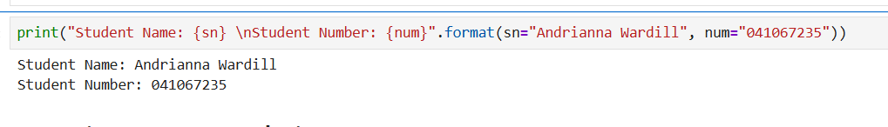
Question 1 – Encapsulation (4 Marks)
Scenario: A Bank Account system must protect balance.
- Create a class BankAccount with a private balance.
- Methods: deposit(amount), withdraw(amount), get_balance().
- Perform one deposit, one withdrawal, and print final balance.
Marks: 1 mark each for class, private variable, methods, and output.
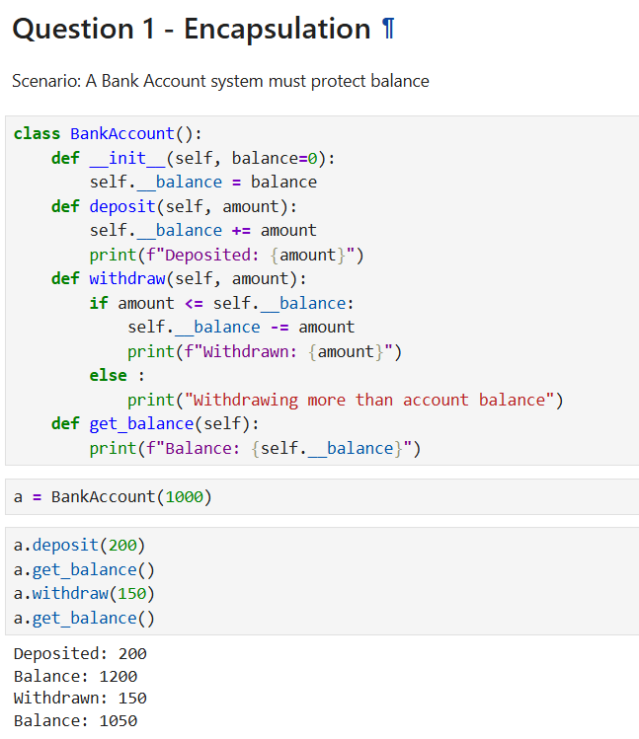

Question 2 – Inheritance (4 Marks)
Scenario: School Management System.
- Base class Person: attributes name, age.
- Derived class Student: adds student_id.
- Method display_info() prints all attributes.
- Create a student object and display info.
Marks: 1 mark each for base class, derived class, inheritance, and output.
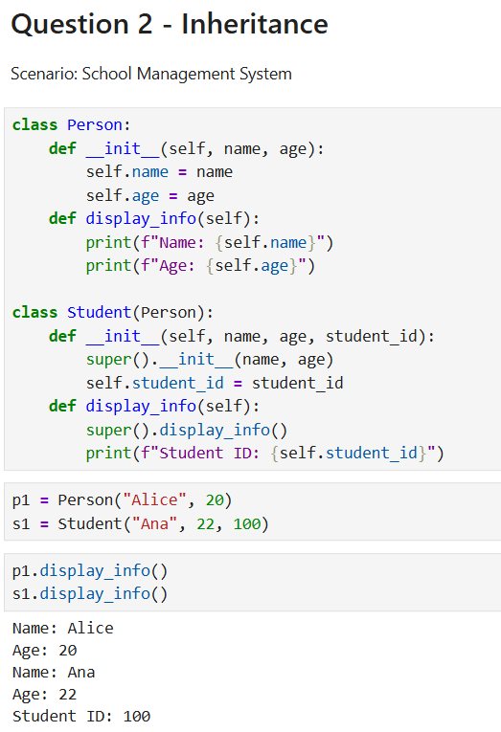
Question 3 – Polymorphism (4 Marks)
Scenario: Different animal sounds.
- Base class Animal with method sound().
- Subclasses Dog and Cat override sound().
- Create both objects and call sound().
Marks: 1 mark each for base class, subclasses, method override, and output.
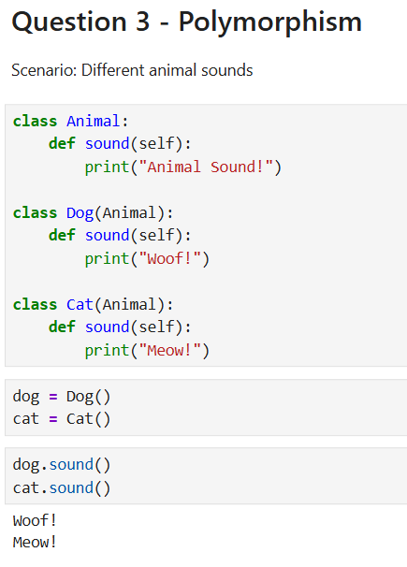
Question 4 – Protected Members (4 Marks)
Scenario: Company employee data.
- Class Employee with protected _salary.
- Subclass Manager accesses _salary.
- Display salary from subclass.
Marks: 1 mark each for class, protected attribute, subclass, and output.
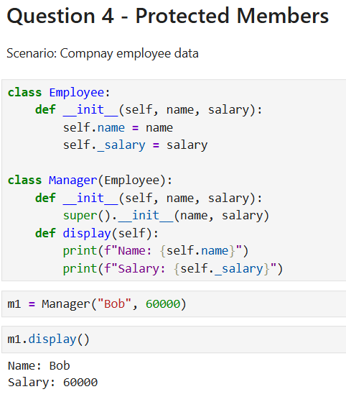
Question 5 – Combined OOP (4 Marks)
Scenario: Vehicle Rental System.
- Base class Vehicle with rent_price().
- Subclasses Car, Bike override rent_price().
- Create objects and print prices.
Marks: 1 mark each for base class, subclasses, polymorphism, and output.
